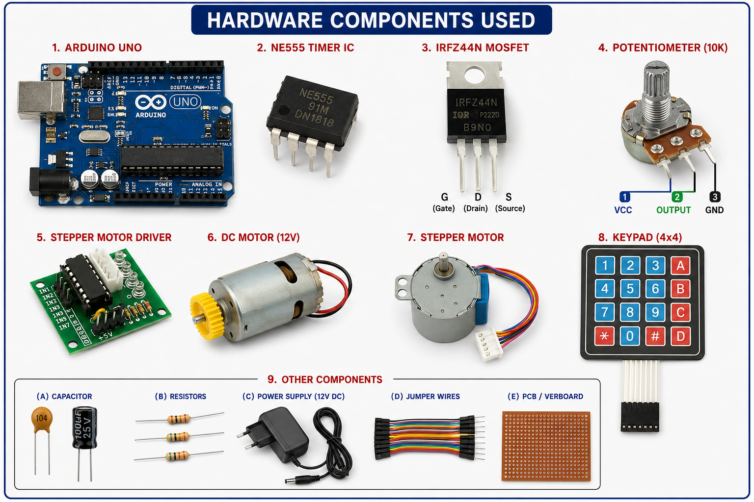
Hardware Components of PWM-Based Flour Mill Motor Speed Controller

1. Arduino Uno
- Acts as the main controller.
- Reads user input from the keypad.
- Controls motor operation and system logic.
2. NE555 Timer IC
- Generates PWM (Pulse Width Modulation) signals.
- Controls the speed of the DC motor by varying the duty cycle.
3. MOSFET (IRFZ44N / IRF540)
- Functions as a power switch.
- Amplifies the PWM signal from the 555 timer to drive the motor.
4. DC Motor
- Represents the flour mill motor.
- Speed is controlled using PWM signals.
5. Stepper Motor
- Provides precise rotational movement.
- Used for mechanical positioning or feed control.
6. Stepper Motor Driver
- Interfaces the Arduino with the stepper motor.
- Supplies the required current to the motor.
7. 4×4 Keypad
- User input device.
- Allows selection of operating parameters and speed settings.
8. Potentiometer
- Adjusts the PWM duty cycle manually.
- Controls motor speed.
9. Capacitors
- Filter noise and stabilize voltage.
- Used in the 555 timer timing circuit.
10. Resistors
- Set timing and current limits in the PWM circuit.
11. Power Supply
- Provides 12 V DC power to the motor and controller circuit.
- Separate supply may be used for Arduino.
12. PCB / Veroboard
- Used to assemble the 555 timer PWM circuit and MOSFET driver stage.

- Hardware Description for Report
The hardware setup consists of an Arduino Uno, NE555 Timer IC, MOSFET driver, DC motor, stepper motor with driver module, keypad, potentiometer, capacitors, resistors, and a regulated power supply. The Arduino processes user inputs from the keypad, while the 555 timer generates PWM signals. The MOSFET amplifies the PWM output to control the speed of the DC motor efficiently. The stepper motor and driver provide precise mechanical control. The complete system offers adjustable motor speed, reduced power consumption, and improved operational efficiency for flour mill applications.

